**Ecommerce Pro**

Video 2 : **Multi Authentication Admin & User Login Registration :**

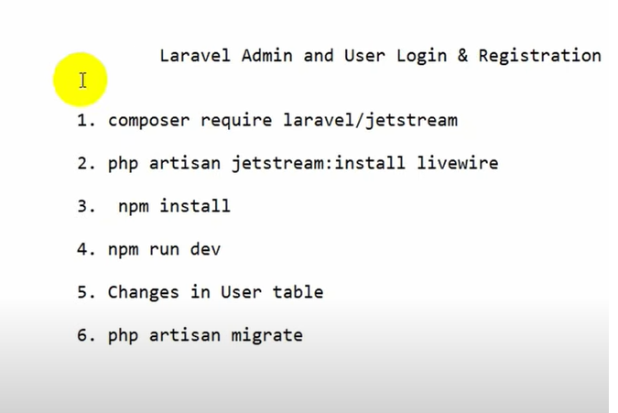

* Resourse > view> auth>register.blade.php (to add phone, address field into register form)
* Models>User.php (to add phone, address into protected fillable)
* App>Actions>Fortify>CreateNewUser.php ( to add phone, address )
* now register two new user
* app>Providres>RouteServiceProvider.php ( replace dashboard to redirect)

route>web.php> create controller (Route::get('/redirect',[HomeController::class,'redirect']);

* create HomeController
* <?php
* namespace App\Http\Controllers;
* use Illuminate\Http\Request;
* use Illuminate\Support\Facades\Auth;
* use App\Models\User;
* class HomeController extends Controller
* {
* public function redirect(){
* $usertype = Auth::user()->usertype;
* if($usertype == '1'){
* return view ('admin.home');
* }
* else{
* return view('dashboard');
* }
* }
* }
* Views>Create Admin folder> create [home.blade.php](http://home.blade.php)
* Views>welcome.blade.php and go to @auth section and **change dashboard to redirect** (to perfectly go to the admin dashboard)

Video 3: **Intrerigate HTML Template:**

* **Laravel template link:** <https://themewagon.com/themes/famms-free-responsive-bootstrap-4-e-commerce-website-template/>
* Dwnload the tamplate and go to public folder > create home folder > paste all tamplate file
* Views>create home folder>create userpage.blade.php

Video 4: **Intrerigate Admin HTML Template:**

* [**https://themewagon.com/themes/corona-free-responsive-bootstrap-4-admin-dashboard-template/**](https://themewagon.com/themes/corona-free-responsive-bootstrap-4-admin-dashboard-template/)Admin dashboard CORONA
* Public a admin folder create korte hobe
* Public>admin> paste all the file (except composer.json)
* Views>admin>[home.blade.php](http://home.blade.php) er vitor index.blade.php file copy paste korbo
* <x-app-layout>
* </x-app-layout>

Logout er code

* Pagination :
* {!! $product->withQueryString()->links('pagination::bootstrap-5') !!}